
UPPER SCHOOL ASSESSMENT 2022

MATHEMATICS ASSESSMENT DATES

Year 12 - Maths Methods Units 3 & 4

Assessment | Date |  | Content
Resp 1 | T1, Wk 6 | w/e 11 Mar | - Differentiation:  - Product/Quotient/Chain Rules  - Trig & Exponential f^{n}s  - 2nd Derivatives | 3.1.1 – 3.1.16
Inv 1 | T2, Wk 2 | w/e 6 May | Areas – LOGO DESIGN
Resp 2 | T2, Wk 5  Non assessment week | w/e 20 May | - Anti-differentiation  - FTOC  - Def Integral/area under curves  - Discrete Random Vars  - Bernoulli/Binomial Dist^{n}s | 3.2.1 – 3.2.16
EXAM S1 | T2, Wk 6/7 | 1/6 – 11/6 | -
Inv 2 | T3, Wk 1 | w/e 22 July | DRVs – GAME DESIGN
Resp 3 | T3, Wk 3 | w/e 5 Aug | - Logarithms  - Continuous Rand Vars  - Normal Distribution | 4.1.1 – 4.1.14  4.2.1 – 4.2.7
Resp 4 | T3, Wk 8  Non assessment week | w/e 9 Sept | - Random Sampling  - Sample Proportions  - Confidence intervals | 4.2.5 – 4.2.7  4.3.1 – 4.3.10
EXAM S2 | T3, Wk 9/10 | 15/9 – 23/9 | -

SPECIAL NOTE – TEST DAYS
Classes doing the same course will have tests on the same day depending on timetable
constraints by arrangement with teachers and students.
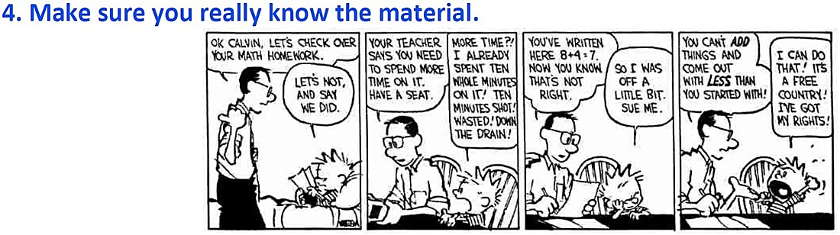

ABSENCE ON ASSESSMENT DAY
Upper School Assessment Policy to be referred to for late submission of work and absences on scheduled assessment days.
♦ Absence from specially scheduled assessment items (including test and examinations) or when a task is due to be submitted must be explained by a medical certificate.
♦ However, the first time a medical certificate is not available a detailed note needs to be given to the classroom teacher immediately upon return (even if the class is not scheduled for the day). This letter will then be verified and approved by the course Head of Department.
♦ The second and any further time a medical certificate cannot be supplied, a letter from a parent must be provided to the appropriate Deputy. The Deputy will then coordinate a committee comprising of him/her and the relating HOD to make a decision regarding how/if the student’s mark will be affected.
♦ Take home part of an Investigation must be handed in prior to the Validation Test. A mark of zero will be given for late submissions past the Validation date.
In order to complete a course and be eligible to receive a grade, students must complete all of the
school’s structured educational program as well as the assessment program for the subject.
WEIGHTING FOR YEAR

Assessment | % of year total | My marks
Response 1 | 10.0
Inv 1 | 10.0
Response 2 | 10.0
EXAM SEMESTER 1 | 15.0
Response 3 | 10.0
Inv 2 | 10.0
Response 4 | 10.0
EXAM SEMESTER 2 | 25.0
